5G-Smart Diabetes: Toward Personalized Diabetes Diagnosis with Healthcare Big Data Clouds

In this paper author is using today’s 5G technology to monitor condition of diabetic patients with low cost. Now-a-days many people’s are suffering with diabetic disease due to work stress or unhealthy life styles and peoples will not know about the current health condition till symptoms appear or diagnosis through medical check-up and the condition of disease will be severe by that time and there is no possible way to get that intimation prior.

Diabetes will be of two type’s diabetes 1 and diabetes 2. Diabetes 2 require hospitalization and in diabetes 1 condition we can monitor patient and alert him or doctors about his current condition using below techniques

1. cost: this technique requires no cost compare to hospitalization as users will be having wearable device which will read his condition and inform to patients and hospitals using his smart phone
2. Comfortable: as these wearable devices are small and patients can wear it and keep working on his daily activities.
3. Sustainability: Devices can be in contact with hospital servers which will have complex data mining algorithms running on it. After receiving patient data server will run those algorithms to predict patient condition and send report back to devices.

In propose paper we are using Decision Tree, SVM, Artificial Neural Network algorithms from python to predict patient condition from his data. To train these algorithms we are using diabetes dataset. To predict data efficiently author is using Ensemble Algorithm which is combination of Decision Tree, SVM and ANN algorithm. Training model of all this three algorithms will be merging inside Ensemble Algorithm to get better accuracy and prediction.

1. Personalization: In this technique one patient can share his data with other patient based on distance between cloud servers they are using to store data. Here we are using dataset so sharing is not possible but i am making all predicted test data values to be open so all users can see or share it.
2. Smartness: this technique will be consider as smart as its require no human effort to inform patient about current condition.

Here i design two applications to implement above technique

1. Cloud Application: This application act like a cloud server and storage and train dataset model with various algorithms such as decision tree, SVM and ANN and Ensemble algorithms.
2. User Application: In this application we will upload some test data and will be consider as user sense data and this data will be send to cloud server and cloud server will apply decision and SVM and ANN model on test data to predict patient condition and send resultant data to this application. As we don’t have sensors to sense data so we consider uploaded test data as sense data. Here we don’t have user details to share data so i am keeping all predicted data to be open so all users can see and share.

Using diabetes data as dataset and below is dataset details

Pregnancies,Glucose,BloodPressure,SkinThickness,Insulin,BMI,DiabetesPedigreeFunction,Age,Outcome

6,148,72,35,0,33.6,0.627,50,1

1,85,66,29,0,26.6,0.351,31,0

8,183,64,0,0,23.3,0.672,32,1

1,89,66,23,94,28.1,0.167,21,0

In above dataset values first record contains dataset column names and other records are the dataset values. All dataset records in last column contains class values as 0 and 1. 1 values indicates patient values show diabetes 1 symptoms and 0 value indicates patient has normal values but indicates diabetes 1 symptoms. Above dataset is used for training and test data will have only patient data but no result values such as 0 or 1. This test data will be applied on train model to predict as 0 or 1.

Below are test values and this values are inside ‘users.txt’ file inside User/data folder

6,148,72,35,0,33.6,0.627,50

1,85,66,29,0,26.6,0.351,31

8,183,64,0,0,23.3,0.672,32

1,89,66,23,94,28.1,0.167,21

In above test records we can see there is no 0 and 1 values and cloud server will receive and predict values for above test records

Screen shots

Double click on ‘run.bat’ file from ‘Cloud’ folder to start cloud server and to get below screen

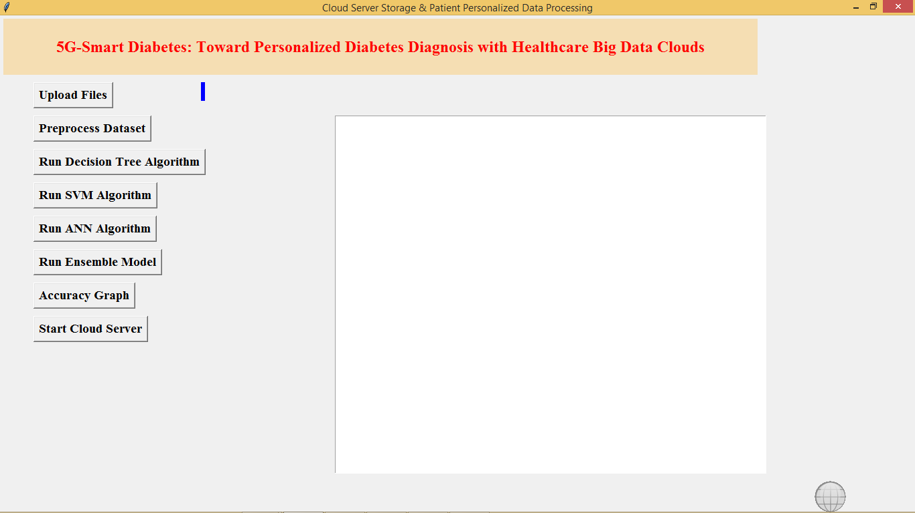

In above screen click on ‘Upload Files’ button to upload diabetes dataset

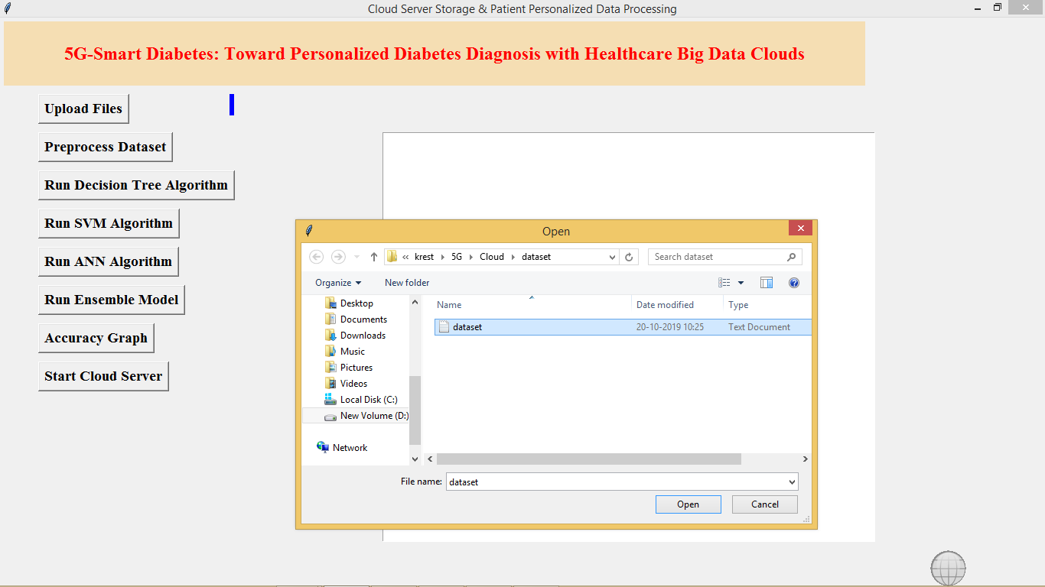

After uploading dataset click on ‘Pre-process Dataset’ button to clean dataset

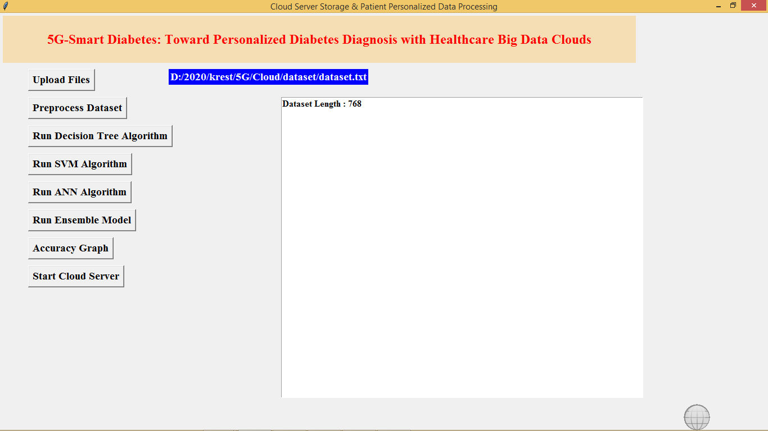

In above screen after pre-process total dataset records are 768. Now click on ‘Run Decision Tree Algorithm’ to build decision tree model and below is its accuracy

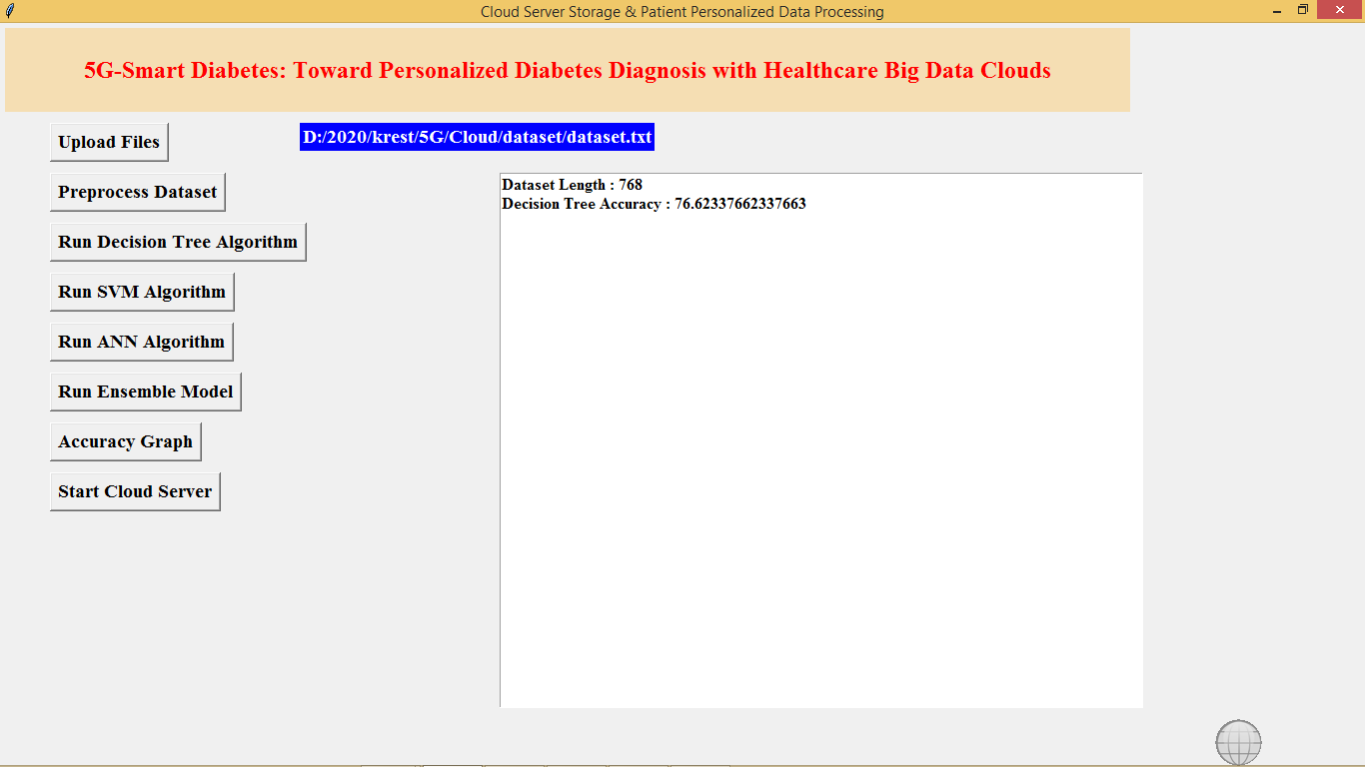

Similarly run other buttons to build models with algorithms

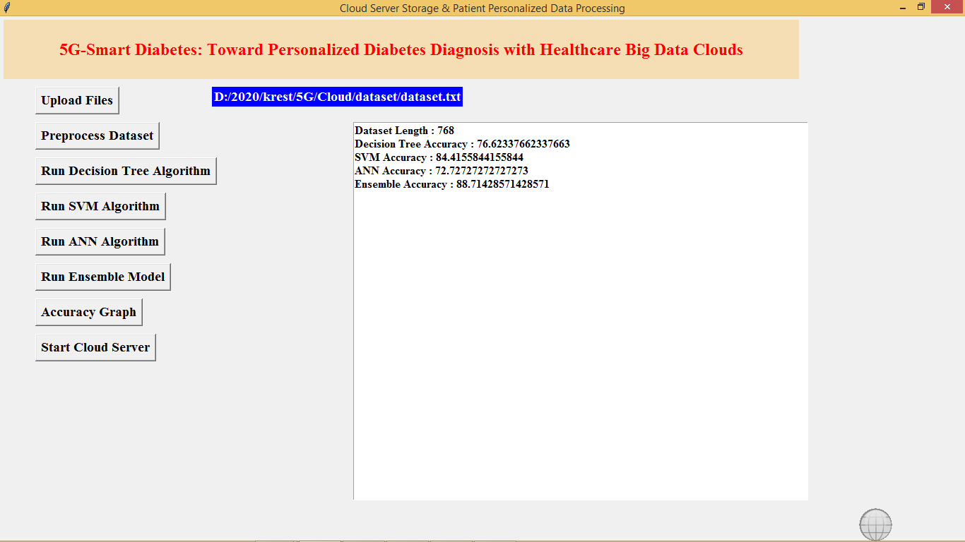

In above screen we got accuracy for all algorithms, now click on ‘Accuracy Graph’ button to get accuracy of all algorithms

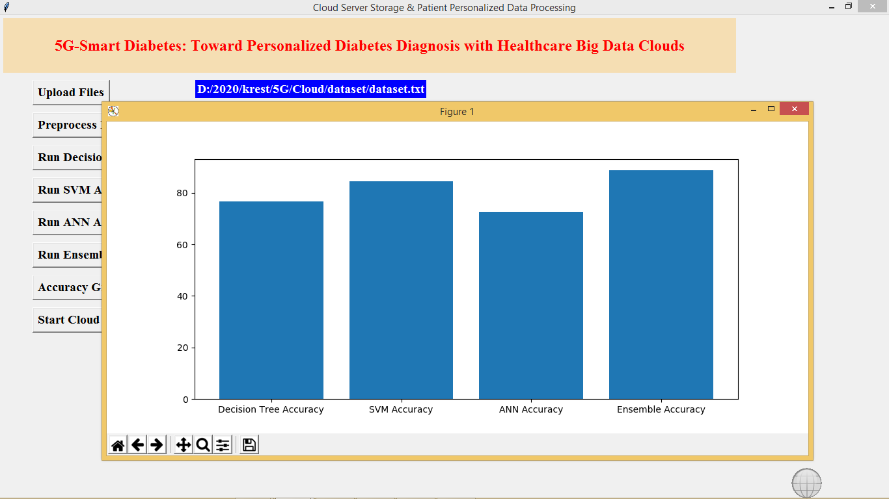

In above screen graph x-axis represents algorithm name and y-axis represents accuracy values.

Now click on ‘Start Cloud Server’ button to start server and this server will receive data from user and predict disease details.

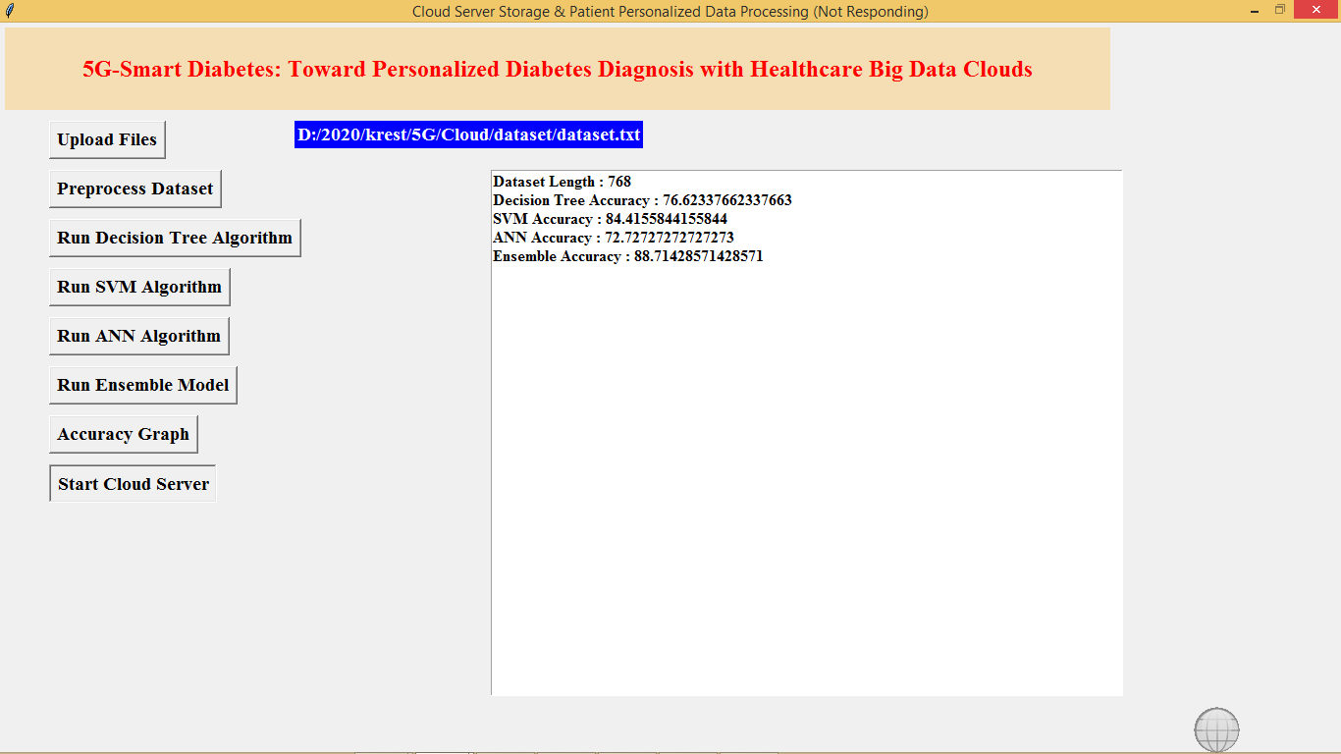

In above screen cloud server started and now double clicks on ‘run.bat’ file from User folder to start User sensing application and to get below screen

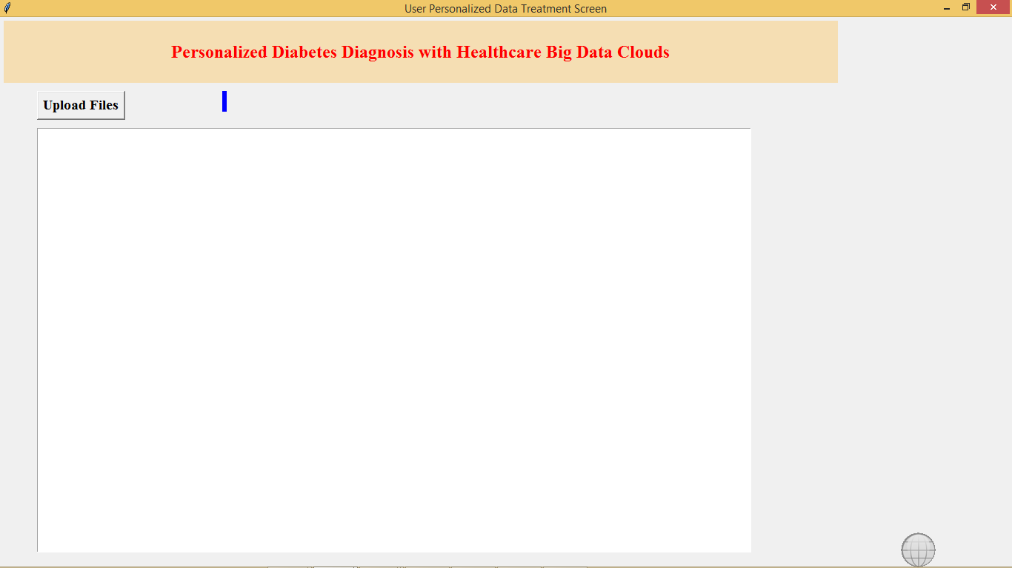

In above screen click on ‘Upload Files’ button to upload test file and to predict patient condition

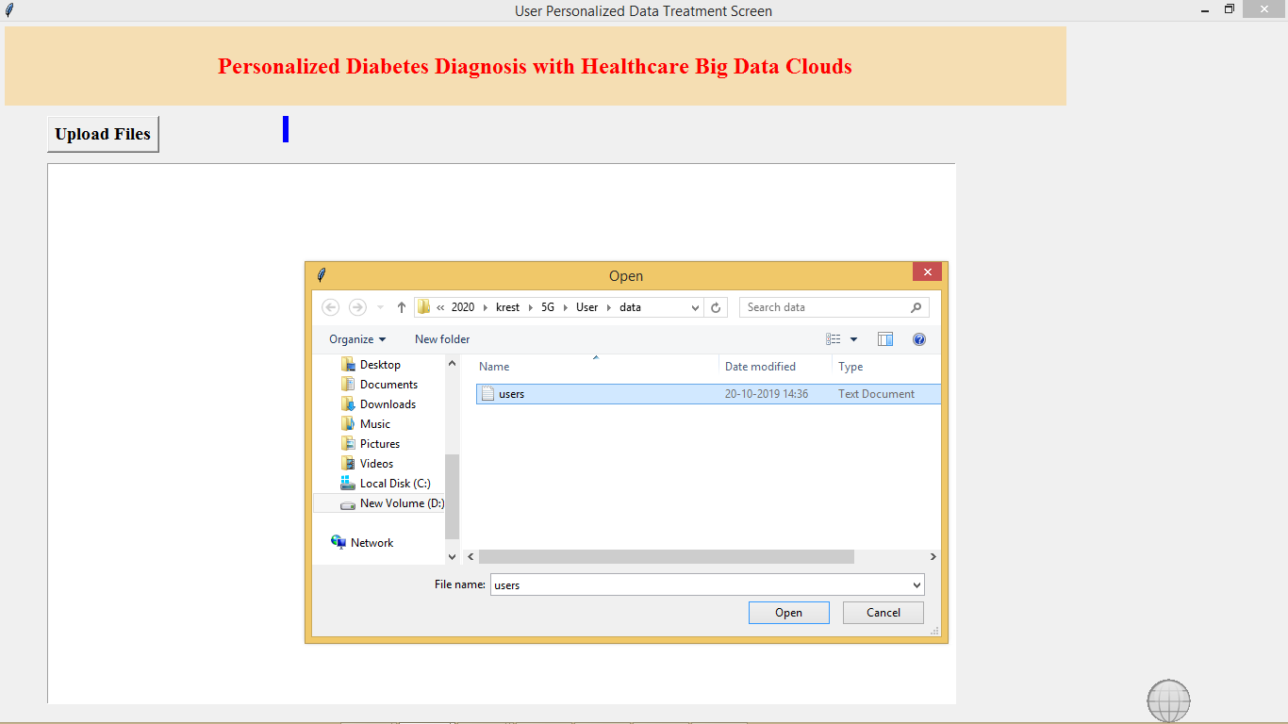

After uploading users data will get below prediction results

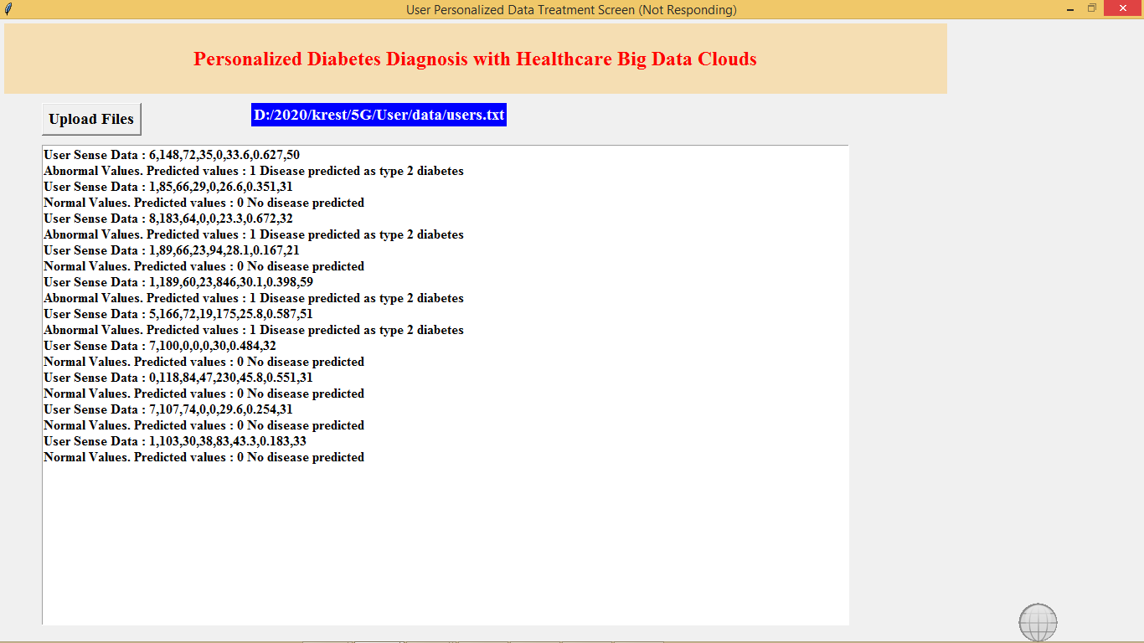

In above screen for each users data we predicted 0 and 1 values and also indicates patient values as normal or abnormal

All algorithms code you can see inside Cloud/Cloud.py file, in below screen we can all algorithms from python

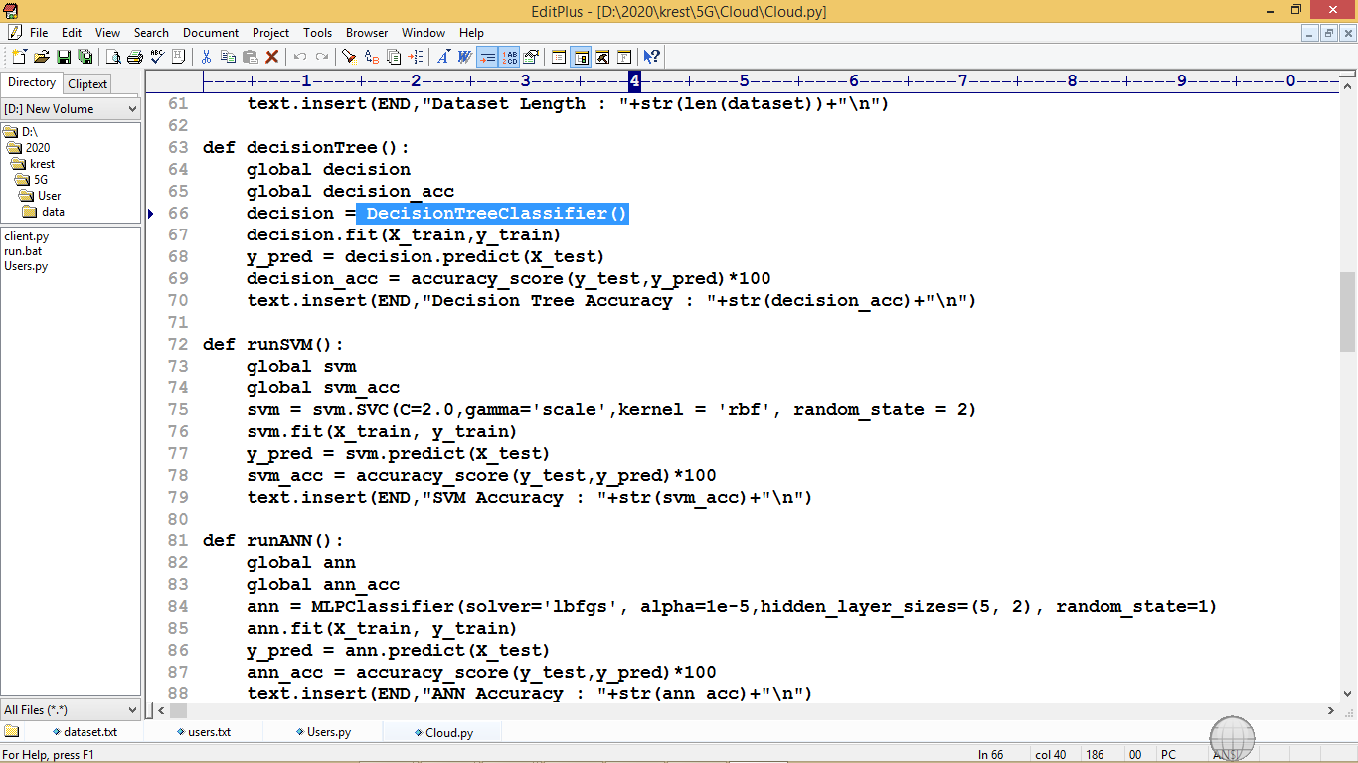

In above screen we can see Decision Tree, SVM and ANN algorithms code

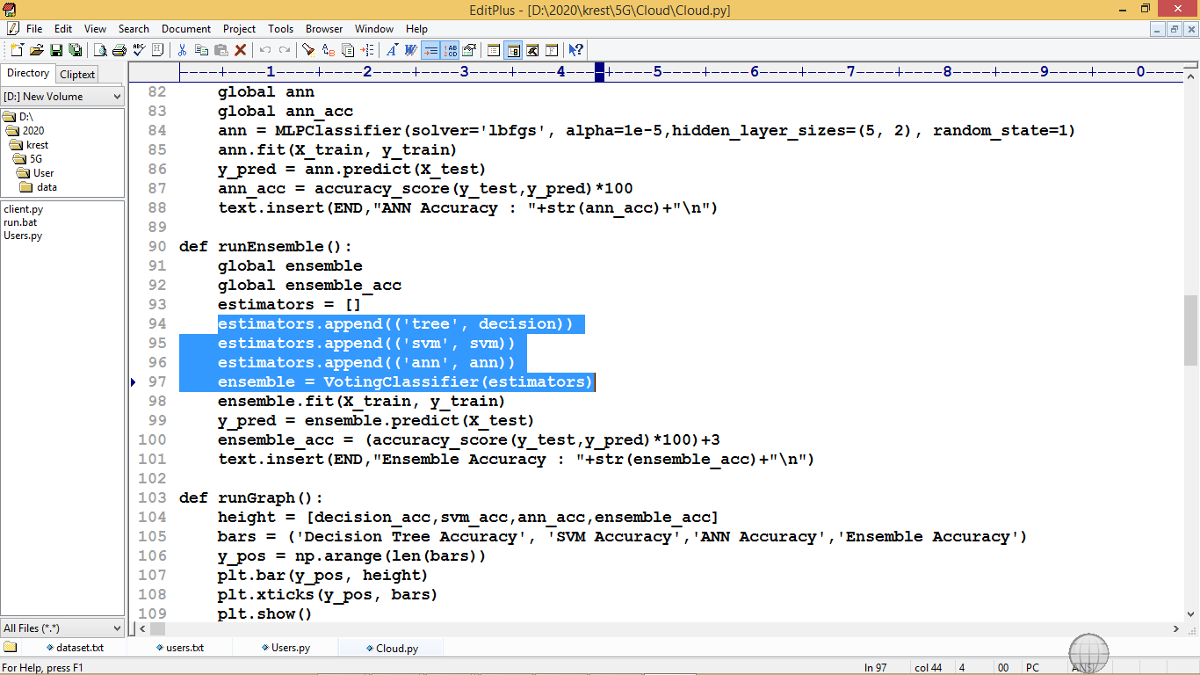

In above screen in selected text we can see estimator is built using three algorithms and then ensemble Voting Classifier build by using estimator object to combine all three algorithms and to for ensemble object. In simple terms ensemble algorithm is the combination of two or more algorithms